**Assessment 2:**

**What am I going to achieve?**

I am looking to achieve a 2d side scrolling platformer that is an endless runner style where the player is only allowed to move forward and jump to avoid obstacles and avoid falling off the platforms.

Score will be based on how far the player is able to get while collecting objects and either jumping over or beating enemies.

There will be a few different enemy types that will challenge how the player is able to get past them (either jumping on or over ), as well as the enemies there will be hazards that the player will need to avoid to survive. These obstacle’s may include traps hidden in the ground, spikes, boulders or fired weapon that are targeted at the player.

The player will have a health system either a number of hits or a heart style so when the player takes damage he will be able to take a few hits before dying.

The player will also be able to pick up weapons and health pick ups. Health pickups will restore a set amount of health each turn.

**Required elements:**

* Health / Hazards
* Movable Character forward and jumping
* Timer / Score
* Different level platforms
* Enemies

**Priority list:**

1. Ground and player movement
2. Enemies
3. Traps
4. Score
5. Health system
6. Refine UI

**Reference Games:**

* Will Hero
* Rider
* Flippy Boat ( rear camera based )
* Mars: Mars

**Will Hero:**

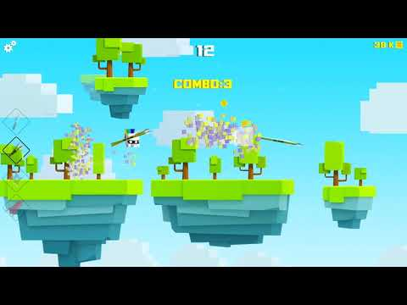

**Rider:**



**Flippy Boat:**

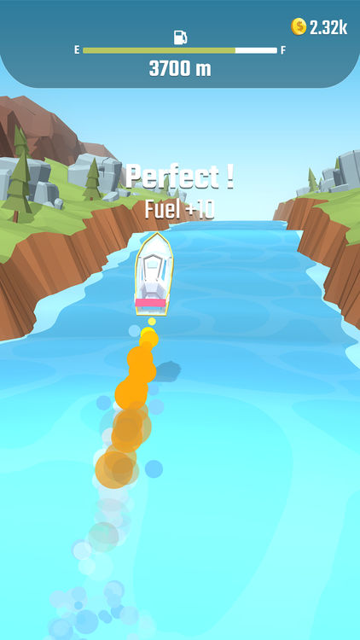

**Mars: Mars**

